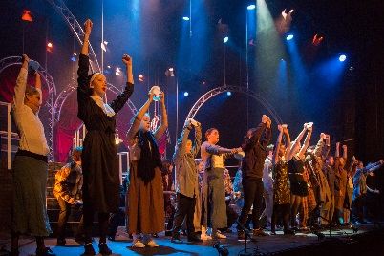
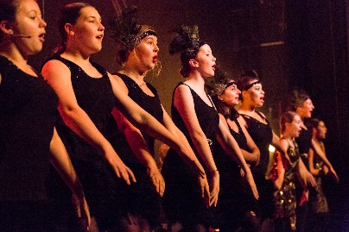
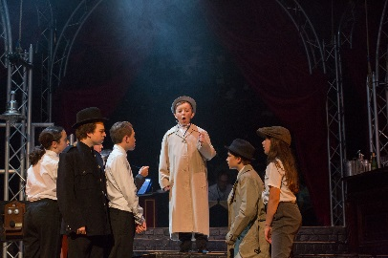
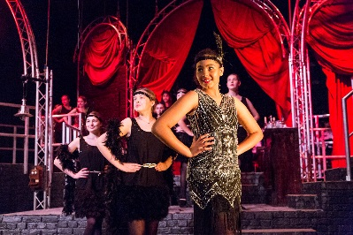

WELCOME TO NEW WIMBLEDON THEATRE STAGE EXPERIENCE 2018
Stage Experience gives young people aged 11-18 the chance to find out what life is like as a professional musical theatre performer. Over the course of the two week rehearsal period you will work with a professional director, choreographer and musical director, producing a high-quality production of Guys and Dolls,
Produced by Creative Learning at New Wimbledon Theatre, our aim is to create an unforgettable experience for all participants.
The fortnight culminates in 3 fully-staged performances at New Wimbledon Theatre!
Stage Experience runs from 6th-18th August 2018
Performances Friday 17th August 7:30pm & Saturday 18th August 2:30 & 7:30pm

To audition for Guys and Dolls you must be available every day Monday 6th August – Saturday 18th August 2018 (excluding weekend of 10^{th/11th}). Places are by audition but no previous musical theatre experience is necessary. However you must be prepared to sing, dance and act. A love of performing is essential.
Auditions for Guys and Dolls will take place on Sunday 20th May at New Wimbledon Theatre.
They last for two to three hours and only those auditioning will be allowed into the auditorium.

Audition Criteria
- Age 11-18 on 6th August
- You must be available to audition on Sunday 20th May
- You must be prepared to sing, dance and act in front of the creative team panel and other auditionees

Criteria for all participants
- You must be available for all dates between 6th to 18th August 2018 (excluding the weekend of 10th/11th)
- You must be able to get yourself to and from the New Wimbledon Theatre in good time for all rehearsals and performances.
- You must have registered your place in advance by 14th May.

How to register
Please complete the registration form in full and return to the address below along with one passport sized photograph.

Registration forms should be received by 14th May to:
Emily Davies, New Wimbledon Theatre, The Broadway, London, SW19 1QG

For further questions or enquiries please contact:
emilydavies@theambassadors.com or call 02085457900

Stage Experience Fees
If you are successful at audition we will notify you by 28th May.
The fees to take part in Stage Experience are £360. There will be a sibling discount of 20%.
You will be required to pay a deposit of £80 by Monday 4th June in order secure your place.

Full Casting will be announced by 11th June.

Audition Information.
Auditions will take place at New Wimbledon Theatre on Sunday 20th May 2018. There will be a morning and an afternoon session lasting two/three hours. You will be notified of your time and further details once you have registered. You do not need to prepare anything for your audition as all material will be taught to you on the day. You must be prepared to sing, dance and act in front of our creative team and the other people auditioning.
Please note that only those auditioning will be allowed in the auditorium.

Frequently asked questions:

What is the closing date for applications?
Application deadline is 6pm on Friday 14th May.

How much does it cost to audition?
Auditions are completely free of charge.

Does everyone who applies get an audition?
Yes, if you register for an audition by returning the application form by Monday 14th May you are eligible to audition on Sunday 20th May.

Do I need to prepare anything for my audition?
No, everything will be taught to you on the day. We recommend that you have a basic knowledge of the Guys and Dolls score prior to your audition.

How will we audition?
At the beginning of your session we will do a physical and vocal warm up. You will be taught part of a song and a short dance and may also work on some acting scenes. You will audition in groups and may be asked to sing or read a solo line.

What do I need to wear for my audition?
Please wear loose comfortable clothing that you can dance in and trainers or dance shoes. Please keep jewellery to a minimum and if you have long hair tie this back. Please also ensure you bring something to drink with you.

What happens after my audition?
You will be informed by on Monday 28th May if you have been successful. We may hold re-call auditions if necessary.

What happened if I’m offered a place?
If you are lucky enough to secure a place in Stage Experience you will be sent further details of rehearsals and fees to take part, which must be paid in advance.

New Wimbledon Theatre
Stage Experience
Audition Registration Form
Staple passport photos here.

Please complete form in block capitals

Full Name: _____________________________________________ Gender: Male/Female
Parent/Guardian Full Name: ___________________________________
Date of birth: _______________ School/College Year ________
School/college you attend (if applicable) ________________________________________________
School/college address:
_____________________________________________________________________________________________________________________________________ Post code: ___________________
Home address: ____________________________________________________________________________________________________________________________________ Post code: _____________________
Contact Telephone Number: _________________________________________________
1st Emergency Contact Name:___________________________Relationship to child:________________ Phone Number:______________
2nd Emergency Contact Name:___________________________Relationship to child:_________________Phone Number:______________
E-mail address: (our preferred method of communication, please write as clearly as possible):
____________________________________________________________________________
Medical Information/Access Requirements Please specify any information of which we ought to be aware of e.g. asthma, allergies, injuries, hearing impairment etc
__________________________________________________________________________________________________________________________________________________________________________________________________________________________________________________________________________________________

Specialism
Please check the boxes of the specialisms that you would like to be considered for in Bugsy Malone.
I am most interested in:
□ Singing □ Dancing □ Acting □ All three

Performance Licence Regulations
In order to comply with Merton Council performance licensing regulations we need to know the number of professional performances (if any) you are performing in between Feb - August 2018 at a professional licensed venue. This does not include any school performances. Professional performances include theatre, modelling & film work.
Please state how many professional performances you have performed in between Feb – August 2018
Please note we are asking the question for licensing reasons, not to find out how experienced you are at performing. Number__________________
Your local authority? (i.e. Merton Council, Surrey County Council)____________________________

Photography and Film Consent 2018
The Ambassador Theatre Group recognises the need to ensure the welfare and safety of all children. In accordance with our child protection policy we will not permit photographs, video or other images of children and young people to be taken without the consent of the guardian/carers and children.
During auditions, rehearsals and performances photography and filming may take place by NWT staff and/or visiting media and sponsors for use by the Theatre and/or local press.

I ………………………..……………….. (guardian/carer) consent to New Wimbledon Theatre photographing or videoing ……………………………………………….. (name of child).

Signature:………………………………………………………………Date: ……………………………

Guys and Dolls Permissions: Please highlight/delete
➢  I do/do not give permission for my child to leave NW Theatre unaccompanied during lunch breaks
➢  I do/do not give permission for my child to leave NW Theatre unaccompanied at the end of the day

Please note that if you do not give permission for your child to leave unaccompanied at the end of the day then we will expect a responsible adult to personally collect. We will not be able to allow your child to meet you in the car park or anywhere off site. If you intend for your child to leave our building to buy themselves lunch then you must have given us permission above to allow your child to do so

If successful at audition, each cast member will receive their very own Guys and Dolls Stage experience T-shirt. Please select your size preference:
- XS
- S
- M
- L
- XL

Please send your completed application to: Emily Davies, New Wimbledon Theatre, 93 The Broadway, Wimbledon, SW19 1QG Or alternatively you can scan and email your application to emilydavies@theambassadors.com.

For further questions or enquiries please contact emilydavies@theambassadors.com
or call 0208 545 7900.

BOPA Medical questionnaire for children and young people performing (Please print clearly).

PERFORMANCE NAME: Stage Experience: Guys and Dolls
PERFORMANCE DATES: Friday 17th August & Saturday 18th August

CHILD'S NAME (IN FULL):......................................................................................
Name of child’s doctor …………………………………………………………………………….
Address of child’s doctor’s ……………………………………………………………………….
Phone number of child’s surgery…………………………………………………………………

1. Has your son/daughter ever had any serious illnesses or operations? If so, please give details.

2. Has he/she had any illness or accidents during the past year requiring hospitalisation or more than five consecutive days off school during the past year? If so, please give details.

3. Does he/she have any difficulty with hearing, eyes (including wearing glasses or contact lenses) or other special needs? If so, please give details.

4. Are you aware of any problems of behaviour, any undue nervousness, any defect of speech, any tendency to fits or fainting attacks? If so, please give details.

5. Does your child require any medicines or emergency medication (e.g. epi-pen or asthma inhalers), diet or special treatment about which the organisation must be informed?

Parent/Guardian’s name:………………………………………………………………

Signature:………………………………………………………………Date: ……………………………

